ES7000 & ClearPath Models

Server | Cabinet Door Style | Badge Identifier | Style Label /  Style Identifier | Disassembly Instructions
ES7000/One Series  ES7000/600  XPC-L | 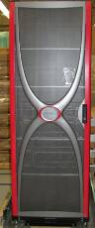 | 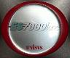 | 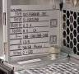  Style names are located  behind cell on left wall.  RAS76004-3BC,  RAS76004-3C,  RAS6001-BAS,  RAS7600401-3BC,  RAS7600401-3C,  RAS600402-POC,  MAR7600401-3C,  MAR6004-POC,  AVA76004-3BC,  AVA76004-3C | End-of-Life Disassembly  Cabinet Level Instructions for Select Models  __________________  End-of-Life Disassembly  Instructions for ES7000/One;  ES7000/600; XPC-L
ES7000 – 7600R  G1, G2, G3, G4 | NA | Various | ES7000 Models:  7600R  7600R G2  7600R G3  7600R G4
ClearPath Dorado 3XX,4XX, 7XX, 8XX  Series | 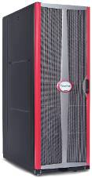 |  | Style names are located  behind cell on left wall  DOR32041-EXP, DOR38041-EXP, DOR38541-EXP,  DOR70041-AXP, DOR70041-BXP, DOR1-BHS | End-of-Life Disassembly  Cabinet Level Instructions for Select Models  __________________  End-of-Life Disassembly  Instructions for Dorado3XX, 4XX, 7XX, 8XX
ClearPath Libra 6XX, 7XX, 8XX Series, and  VSE 550 |  |    | Style names are located  behind cell on left wall  EDN304-APC, EDN9304-APC,  EDN304-BPC, EDN9304-BPC,  VSE550304-APC | End-of-Life Disassembly  Cabinet Level Instructions for Select Models  __________________  End-of-Life Disassembly  Instructions for Libra 6XX; FS1800; VSE 550

Server | Cabinet Door Style | Badge Identifier | Style Label /  Style Identifier | Disassembly Instructions
ES7000/500 Series.  ClearPath Libra 5XX,  VSE 500, FS1400, FS1600 | 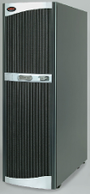  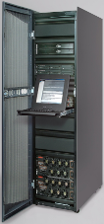 | 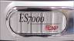      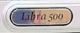 | 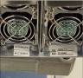  Style names are located  on front fan assembly  Freestanding cells  CELxxx-F15*,  CELxxx-F20*,  CELxxx-V15*,  CELxxxV20*  Rack Mounted Cells  CELxxxxx-F15*,  CELxxxxx-F20*,  CELxxxxx-V20*,  CELxxxxx-V28  LIB580804-BAS,  LIB581608-BAS,  LIB583216-BAS,  FS141x-xxx  FS160805-BAS,  FS161608-BAS  * where x =  number representing  processor count,  speed, cache size | End-of-Life Disassembly  Instructions for  ES7000/5XX; Libra 5XX; VSE 500; FS1400; FS1600
ES7000/400 Series | 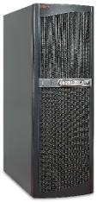 |  | 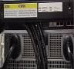  Style names are located  on rear main assembly  CAS7000405-CR,  CAS7000410-ES,  CAS7000420-GS,  CAS7000430-GD,  CAS7000440-GD,  ACLxxxxxxx-GS*,  ACLxxxxxxx-GD*  ACLxxxxxxx-GD2*,  ACLxxxxxxx-GS2*  * where x =  number representing  processor count,  speed, cache size | End-of-Life Disassembly  Instructions for ES7000/4XX

Server | Cabinet Door Style | Badge Identifier | Style Label /  Style Identifier | Disassembly Instructions
ES7000/Classic, ClearPath Dorado 2XX | 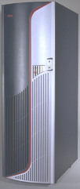 | 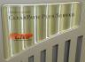 | 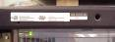  Style names are located  on upper left front  cabinet frame assembly  APA1100-BAS,  APA21001-BAS,  APA21002-BAS,  APA2100-BAS,  APA278002-BAS,  APA3016BAS,  APA7120-BAS,  CMP7xxxxxxX-GS*,  CMP7xxxxxxX-GD*  *where x =  number representing  processor count,  speed, cache size | End-of-Life Disassembly  Instructions for  Dorado 2XX

Dell Based D4x00, D63x0, D83x0, L4x00, L63x0, L83x0 ClearPath Models

Server | Cabinet Door Style | Badge Identifier | Style Label /  Frame Identifier | Disassembly Instructions
Dell Servers in 42U Frames | 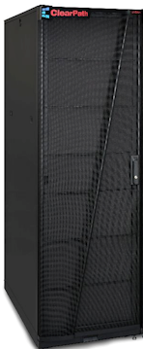 | 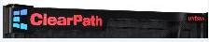 | Style names are located  on upper left front  cabinet frame assembly  RCK4219421-CAB RCK4219422-AXP | End-of-Life Module Disassembly  Instructions for Dell Based Clearpath Systems  See ClearPath Dorado 3XX,4XX, 7XX, 8XX  Series for basic End-of-Life Disassembly  Cabinet Level Instructions

ES3000 (Dell Power Edge) Models

Server | Unisys Model Name | Dell Equivalent  Model Name | Description | Disassembly Instructions
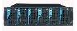 | ES3005 | PE1655MC | Blade Server | Dell PowerEdge Tear-down Instructions
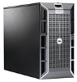 | Dell Branded Only | PE1900 | 2-socket, Quad-core Tower Server | Dell PowerEdge Tear-down Instructions
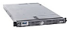 | ES3215L | PE1950 | 2-socket, Quad-core 1U Rack Server | Dell PowerEdge Tear-down Instructions
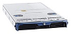 | Dell Branded Only | PE1955 | 2-socket, Quad-core Blade Server | Dell PowerEdge Tear-down Instructions
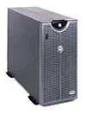 | ES2026 | PE2500 | 2 processor/5U Server | Dell PowerEdge Tear-down Instructions
 | ES2026L | PE2550 | 2 processor/2U Server | Dell PowerEdge Tear-down Instructions
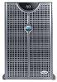 | ES3020 | PE2600 | 2 processor/5U Server - XP | Dell PowerEdge Tear-down Instructions
 | ES3020L | PE2650 | 2 processor/2U Server | Dell PowerEdge Tear-down Instructions
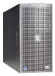 | ES3120 | PE2800 | 2 processor/5U Server | Dell PowerEdge Tear-down Instructions
 | ES3120L | PE2850 | 2 processor/2U Server | Dell PowerEdge Tear-down Instructions
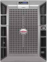 | ES3220 | PE2900 | 2-socket, Quad-core Tower Server | Dell PowerEdge Tear-down Instructions
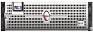 | ES3220L | PE2950 | 2-socket, Quad-core 2U Rack Server | Dell PowerEdge Tear-down Instructions

Server | Unisys Model Name | Dell Equivalent  Model Name | Description | Disassembly Instructions
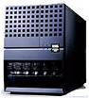 | ES2046 | PE6400 | 4 Processor Server | Dell PowerEdge Tear-down Instructions
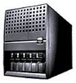 | ES2046L | PE6450 | 4 Processor Server | Dell PowerEdge Tear-down Instructions
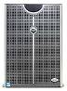 | ES3040 | PE6600 | 4 Processor/7U Server | Dell PowerEdge Tear-down Instructions
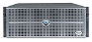 | ES3040L | PE6650 | 4 Processor/4U Server | Dell PowerEdge Tear-down Instructions
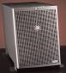 | ES3140 | PE6800 | Quad Socket, Dual Core Tower Server | Dell PowerEdge Tear-down Instructions
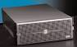 | ES3140L | PE6850 | Quad Socket, Dual Core 4U Rack Server | Dell PowerEdge Tear-down Instructions

Other Models

Server | Unisys Model Name | Dell Equivalent  Model Name | Description | Disassembly Instructions
FS1100 | FS111x-xx | PE6600 | SVR:Financial dual Xeon 2.2GHz with 2MB L3 Cache | Dell PowerEdge Tear-down Instructions
FS1300 | FS131x3x-xxx | PE6800 | Quad Socket, Dual Core 4U Rack Server | Dell PowerEdge Tear-down Instructions
FS1700  Libra 400 | ES3220 | PE2900 | SVR:ES3220 2.83GHz FSB 1333MHZ 2X6M CACHE | Dell PowerEdge Tear-down Instructions
Libra 300 | ES3140 | PE6800 | SVR: dual 3.16GHz with 1MB L3 Cache, or four 3.66 GHz with 1MB L3 Cache | Dell PowerEdge Tear-down Instructions

